

**Disaggregating Fiscal Policy by Ideological Partisanship: An Empirical Analysis of Conservative and Liberal Fiscal Policies (US) on S&P 500 Returns**

**LORCAN MANUEL GOURLEY**

**SUBMITTED IN PART FULFILMENT OF THE DEGREE OF**

**MSc IN**

**FINANCE AND DATA ANALYTICS**

**FINP099**

**SEPTEMBER 2025**

Name: Lorcan Gourley

Registration Number: 2812904

**Submission**

**I confirm** that I have today submitted 1 electronic version in PDF format to Turnitin.

**Dissertation format**

**I confirm** that the dissertation is in the format outlined in the Dissertation Notes for students. In particular, it:

✔ is 1.5 or double-spaced on both sides of A4 paper

✔ has margins of at least 2.5cm (left) and 2.5cm (right)

✔ has pages numbered consecutively

✔ **with each chapter starting on a new page**

✔  **is properly referenced in Harvard notation**

✔ includes:

✔ title page

✔ an abstract

✔ Table of contents

✔ a fully detailed bibliography in alphabetical order by surname

The total word count excluding bibliography is 10679

**Please tick ✔ each item to confirm**

**I understand** that my dissertation may be placed on the University Library catalogue on line and accessed by staff and students after I have finished the programme.

**Plagiarism**

**I am aware** of the university’s policy on plagiarism ([Academic Integrity Policy and Academic Misconduct Procedure](https://www.stir.ac.uk/about/professional-services/student-academic-and-corporate-services/academic-registry/academic-policy-and-practice/quality-handbook/academic-integrity-policy-and-academic-misconduct-procedure/)), and **I certify** that this dissertation is my own work, and that I can provide an audit trail back to any data I have collected if requested.

**I confirm** that I have not sourced or used any information from any online 'essay' provider or any other third party in my assignment.

**I hereby authorise** the department to undertake any steps to check the veracity of this statement, including the use of any plagiarism detection software or services

**I hereby consent** to the processing of my personal data (including my name, registration number and other necessary information) for these purposes.

**Use of AI generated content**

I acknowledge that:   
1. No content knowingly generated by AI technology has been presented as my own work in this submission

Signed: 

Date: 17th September 2025

# Acknowledgements

I would like to thank Dr Patrick Herbst for his continuous support and guidance throughout the entirety of writing my dissertation, his advice and support was invaluable to the completion of this research.

I would like to thank my mother Gemelda Gourley, as without her support, completing my Masters degree would not have been possible and she has given me the academic tools to pursue my goals..

I want to give my deepest appreciation to my girlfriend Mabel Thompson. She has been by my side through my entire undergrad and Masters, pushing me to be the best version of myself and helping me achieve goals I didn’t think was possible. I am forever grateful for her unwavering enthusiastic support, even through late night library shifts, job searches and she makes sure I can always put my 100% energy into everything I tackle.

I would like to thank my family members; my dad John Gourley, my aunt Colette Ruckert-Hennen, and my uncles; Edward Gourley, Martin Gourley, John Sweeney and Lawrence Gourley. They have each individually supported me through this year in their own unique ways, whether offering life advice, emotional support, work advice or an ear to talk to, and I am grateful to have the support of my family always by my side.

Lastly, I would like to thank my gym partners and friends Sam O’Grady, Dustin Lau and Harry Proudlove. The time we had in the gym was short lived, but the conversation (and on some days the lack of) and motivation you provided on the tougher days in and outside of the gym will forever be appreciated. Stay small and prosper.

# Abstract

This research employed a Pooled Vector Autoregression (VAR) with Cholesky recursive ordering to examine the effects that fiscal taxation and spending shocks have on the S&P 500 during Conservative or Liberal regimes, in the US during a time-period 1971 to 2013. This study provides new insight into how fiscal policy influences stock prices by looking into a largely unexplored question which arises from Tavarez and Valkanov (2003): does disaggregating fiscal policy through partisan ideology make its effects on asset prices more clear?

This research follows the approach of the Tavarez and Valkanov (2003) study through using impulse response functions (IRFs) and forecast error variance decompositions (FEVDs) as the main performance measures. Altering the lag length, changing the control variables and re-ordering the variables are used to assess the robustness of the results. Analysing data from 1971 to 2013 for the S&P 500, shows that disaggregating taxation and spending according to ideological partisan orientation in the US (Conservative or Liberal) can make the fiscal policy effect on asset prices more clear. The results showed that in the first year after a shock the spending effects in Conservative regimes was ambiguous, whereas spending in Liberal regimes had a statistically significant negative effect on the S&P 500, at a 1 to 5 year time frame both regimes showed a positive effect, which was significant. For taxation under Conservative regimes there was an initial positive effect, whereas Liberal regimes had a mainly negative effect and the long-term effect for both regimes was negative. The results show that disaggregating fiscal instruments through ideological partisan orientation provides a more clear picture.

# LIST OF TABLES

**Table 1: The descriptive stats of the variables used in the model………………………p22**

**Table 2: Results of the first stationarity test on all variables……………………...……..p29**

**Table 3: Results of the differenced variables stationarity tests………………………….p29**

**Table 4: Shows the FEVD response of S&P 500 returns during both regimes using the baseline model…………………………………………………………………………………….p35**

**Table 5: Shows the FEVD response of S&P 500 returns during both regimes using the additional variables robustness check……………………………………………………….p39**

**Table 6: Shows the FEVD response of S&P 500 returns during both regimes using the three lags robustness check……………………………………………………………………p53**

**Table 7: Shows the FEVD response of S&P 500 returns during both regimes using the five lags robustness check……………………………………………………………………..p56**

**Table 8: Shows the FEVD response of S&P 500 returns during both regimes using the variable reordering robustness check………………………………………………………..p59**

# LIST OF FIGURES

**Figure 1: Shows the IRF of the effect to S&P 500 returns after a spending shock during both regimes using the baseline model………………………………………………………p33**

**Figure 2: Shows the IRF of the effect to S&P 500 returns after a tax shock during both regimes using the baseline model…………………………………………………………….p34**

**Figure 3: Shows the IRF of the effect to S&P 500 returns after a spending shock during both regimes using the additional variables robustness check………………………....p37**

**Figure 4: Shows the IRF of the effect to S&P 500 returns after a tax shock during both regimes using the additional variables robustness check………………………………..p38**

**Figure 5: Shows the IRF of the effect to S&P 500 returns after a spending shock during both regimes using the three lags robustness check…………………………………..…p51**

**Figure 6: Shows the IRF of the effect to S&P 500 returns after a tax shock during both regimes using the three lags robustness check…………………………………………....p52**

**Figure 7: Shows the IRF of the effect to S&P 500 returns after a spending shock during both regimes using the five lags robustness check……………………………………….p54**

**Figure 8: Shows the IRF of the effect to S&P 500 returns after a tax shock during both regimes using the five lags robustness check……………………………………………...p55**

**Figure 9: Shows the IRF of the effect to S&P 500 returns after a spending shock during both regimes using the variable reordering robustness check………………………….p57**

**Figure 10: Shows the IRF of the effect to S&P 500 returns after a tax shock during both regimes using the variable robustness check………………………………………………p58**

# Table of Contents

**Acknowledgements 3**

**Abstract 4**

**LIST OF TABLES 5**

**LIST OF FIGURES 6**

**Table of Contents 7**

**CHAPTER 1: INTRODUCTION 9**

1.1 Background 9

1.2 Research Objectives 10

1.3 Rationale for the Research 10

1.4 Methodology 11

**CHAPTER 2: LITERATURE REVIEW AND HYPOTHESES DEVELOPMENT 12**

2.1 Introduction 12

2.2 Fiscal Policy 12

2.2.1 Ideological Conservative vs Liberal Fiscal Policies 12

2.2.2 Fiscal Policy and the Effect on the S&P 500 14

2.3 Modelling 15

2.3.1 Review of Modelling on Market Returns 15

2.3.2 Dummy Variables, Data Splitting, and Multiple Regimes 17

2.4 Testable Hypothesis 18

2.4.1 Conservative Regime 19

2.4.2 Liberal Regime 19

2.4.3 Conservative and Liberal Comparison 19

2.5 Conclusion 19

**CHAPTER 3: RESEARCH DESIGN 21**

3.1 Introduction 21

3.2 Data Description 21

3.3 Liberal and Conservative Classification 23

3.4 Validation of Choices 26

3.4.1 Control Variables 26

3.4.2 Estimation Method 26

3.4.3 IRF, FEVD, and Bootstrapping: Results Validation 27

3.5 Methods of Estimation 27

3.5.1 Stationarity Tests 28

3.5.2 Pooled VAR Model with Cholesky Identification 30

3.5.3 Model Specification 31

3.6 Conclusion 31

**CHAPTER 4: RESULTS 32**

4.1 Introduction 32

4.2 Results from the Pooled VAR model 32

4.3 Robustness Checks 36

4.3.1 Additional Variables Robustness Check 36

4.3.2 Lags Robustness Checks 40

4.3.3 Reordering Robustness Check 41

**CHAPTER 5: DISCUSSION AND CONCLUSION 42**

5.1 Introduction 42

5.2 Study Hypotheses 42

5.3 What do the Results Imply 43

5.4 Limitations 44

5.5 Recommendations for Further Research 45

5.6 Conclusion 45

**BIBLIOGRAPHY 47**

**APPENDIX 1 51**

# CHAPTER 1: INTRODUCTION

## 1.1 Background

A long standing question regarding US fiscal policy is whether government partisan affiliation has a meaningful influence on the formation of fiscal policies. Jacobson (2016) believed that the 2016 US presidential election had notable consequences such as a departure from party loyalty when it came to policy decisions. However, Potrafke (2017) challenged this belief and found that there are no important correlations at the national level between fiscal policy outcomes and government partisan affiliation. This is further supported by the findings of Herring (1938) and Cusack (1997, 1999) who argued that the impact of government partisan affiliation has waned over time and fiscal policies instead are centred on what is economically and politically feasible within current society.

Fiscal policy, such as government taxation and spending, is a key method used to stabilise output[1]. However, the implementation of fiscal policies does not only affect macroeconomic variables like inflation but also asset markets like the S&P 500. This is due to investors adjusting portfolios to reflect their economic expectations. The study carried out by Tavarerz and Valkanov (2003), exploring a possible correlation between disaggregated fiscal policy and financial markets, showed that increased taxation caused a persistent negative effect on the S&P 500. These researchers hypothesised this was due to portfolio rebalancing, reduced after-tax returns and lower corporate earnings. Alternatively, spending shocks displayed a positive effect but the significance was weaker, which could be explained by the resultant growth stimulus. This paper highlighted the importance of fiscal policies as a cause of market behaviour, additionally displaying how the two channels of fiscal policy, spending and taxation, affect asset prices diversely. The researchers state that a more detailed explanation for asset market behaviour could be obtained through disaggregating the variables by partisan fiscal differences or by left/right wing periods of government.Whilst this has been widely explored[2], it presents the idea that a disaggregation of fiscal variables can drive further insights.

Therefore this paper employs a Pooled VAR with Cholesky recursive ordering on fiscal variables, disaggregated by ideological partisan regimes, to measure the differences between ideological Conservative and Liberal (US) fiscal policies on the S&P 500.

## 1.2 Research Objectives

This research is built on the understanding that ideological Liberal and Conservative fiscal policies are different and therefore might be assumed to have differing effects on asset markets. If aggregated taxation and spending are analysed together as a composite variable, the results found may be unclear due to the combining of the data arising during different regimes. This present study therefore aims to observe the effects that ideologically different fiscal policies had on the S&P 500 in the time period 1971 to 2013. The specific objectives are:

* Exploring how to identify Fiscal policy as Conservative or Liberal through disaggregating Taxation and Spending.
* Investigating whether the nature of the US Fiscal policy regime, Conservative or Liberal has differing effects on the S&P 500.

## 1.3 Rationale for the Research

The effects of monetary policy and its influence on stock markets has been extensively researched, whereas, fiscal policy and its stock market relationship has been studied less, as highlighted by Laopodis (2009). Therefore fiscal policy and its influence on macroeconomic variables and financial markets is receiving growing attention, as shown through Singapore’s specific focus on gaining a deeper understanding of the relationship between fiscal policy and macroeconomics[3].

The pivotal Tavarez and Valkanov (2003) paper concluded that a disaggregated view could be critical for expanded research within this area, stating that partisan fiscal differences may give rise to diverging effects that fiscal policy has on financial markets.

Cusack (1999) stated that between 1861 and 1991, government party affiliation had a diminishing influence on fiscal policy and the economic context was becoming increasingly more important. This rationale was built on the Tavarez and Valkanov (2003) paper to disaggregate fiscal instruments in an economically meaningful way by attempting to separate policies into ideologically Liberal or Conservative regimes rather than party affiliation.

## 1.4 Methodology

The methodology for this research uses quantitative and qualitative variables. It involves analysing US quarterly data spanning the period from 1971:1 to 2013:4, using a Pooled VAR with Cholesky recursive ordering as the main regression method employed. This has the ability to capture the effects of fast moving markets and the unique effects ideologically Conservative and Liberal fiscal policy regimes might have on the S&P 500. To ensure the data is stationary, Phillip-Perron and Augmented Dicky-Fuller tests are carried out to ensure variables are stationary, in line with the studies of Tavarez and Valkanov (2003) and Granger et al. (1974). Robustness checks are also carried out to ensure the results are consistent across a variety of different economic assumptions and this involves changing the quantity of lags, additional control variables and a re-ordering of the variables. This ensures we can accurately postulate about what the data could say.

# CHAPTER 2: LITERATURE REVIEW AND HYPOTHESES DEVELOPMENT

## 2.1 Introduction

Although there is a vast amount of research being carried out currently, there are conflicting viewpoints regarding the effect of fiscal policy on asset markets. Many studies have tried to decipher the correlation using different methodological approaches, using a range of control variables or models, but many have been inadequate and there is still not an agreed opinion on which method best produces a robust answer. This could be due to the studies using aggregated fiscal variables rather than separating out the fiscal methods into economically meaningful regimes, such as Liberal or Conservative.

To guide this research, this literature review has two key sections. The first being a review of fiscal policy, specifically what makes it ideologically Conservative or Liberal, and how fiscal policy affects the S&P 500. The second regards the methodological approach that is appropriate for measuring these effects, such as the model type, and the ways in which the sample can be divided. This is followed by a hypothesis development and lastly a conclusion.

## 2.2 Fiscal Policy

### 2.2.1 Ideological Conservative vs Liberal Fiscal Policies

Research by Maddox et al. (1984 p5) proposed a binary definition for Liberal and Conservative policies. Under this definition, a policy is considered Liberal if it has characteristics of government intervention and expansion of personal freedoms while, a policy is considered Conservative if it aims to reduce government involvement and prioritise traditional structures. This basis offers a useful starting point when trying to ideologically identify Liberal and Conservative fiscal policies.

Regarding economic policy, Cusack (1999, p1) stated “parties on the left are seen as prone to engage recklessly in deficit spending, whereas parties on the right are seen as fiscally prudent.” This perspective was seconded by Cowart (1978 p432), who tested the view that left governments are often thought to tolerate large budget deficits to pursue dramatic expansions. Although this study was conducted with European Governments, it provides a relevant foundation for assessing ideological classifications.

Other research reinforces this ideological understanding, with Persson et al. (1995), who suggested that Liberal Governments lead to higher spending. Cusack concluded that Liberal governments increase public spending when there is high unemployment. This highlights that higher unemployment correlates with Liberal governments taking a looser fiscal stance to attempt to stimulate demand. Cusack built on this idea stating that during periods of low unemployment, a Liberal Government will tighten its stance to try to prevent the economy from overheating and generating an unsustainable public debt.

There seems to be a general agreement across academics on the definition and classification of fiscal policy as either Conservative or Liberal, based not solely on party affiliation but on behavioural patterns and ideological beliefs. This is highlighted by the similarities found in the literature in the responses to economic conditions such as high and low unemployment. Liberal policy usually has a countercyclical approach, loosening fiscal constraints in downturns to stimulate demand, whilst Conservative policy favors fiscal restraint when there are economic pressures. There is a limit however to the usefulness of this approach, as relying solely on this method may lead to misclassification as it ignores the context behind budget changes. To minimise this constraint, the intent and nature of spending, as well as tax decisions, will need to be analysed to accurately assess the ideological orientation.

There is further agreement on the classification of warfare spending as ideologically Conservative, despite contributing to the deficit, as it does not contribute to the expansions of personal freedoms Maddox et al. (1984). Bohn (2008) agreed, highlighting the nuances within this area of research. These distinctions are also displayed when classifying tax policy. Andersson (2023) stated that, during 1870-1945, traditional left-wing parties relied less on taxes which fall on the poor, such as consumption taxes, but focused more on taxes that targeted the rich, like income tax. This idea was supported recently by Alesina et al. (2018), who demonstrated the differing approach towards redistribution, with Conservatives opposing and Liberals supporting redistribution and taxation.

The nuance is furthered by Rudolph (2009), as he analysed the 2001 W. Bush tax cuts. This disproportionately benefited the wealthy, both reducing redistribution and taxation, in alignment with Conservative ideology despite resulting in an increase in the federal deficit. This highlighted that there is a general consensus for what characteristics typically are featured within each regime, there is also an agreement on specifics that delineate themselves from the original classification.

Barnes (2014) expounded on the idea of what makes policy progressive, stating as long as the tax scheme is progressive, any increase in the share of taxes taken by the government will increase redistribution. Piketty and Saez (2007) agreed with this definition of redistribution but built on it stating that a tax system is progressive if the after-tax income is more equally distributed than the before-tax income and if the opposite is true then it is regressive.

In conclusion, the current literature on ideological Conservative vs Liberal fiscal policies highlights that in order to evaluate fiscal decisions the purpose and structure must be analysed. An increase in a deficit alone is not ideologically Liberal and the context must be examined. Without this context an attempt to categorise fiscal policies may lead to a misleading conclusion.

### 2.2.2 Fiscal Policy and the Effect on the S&P 500

Fiscal policy is taking a more leading role in the shaping of macroeconomic outcomes and its impact on financial markets is receiving a growing amount of academic attention. While there is now a substantial body of literature examining the relationship between fiscal policy and stock market performance, the theoretical and empirical findings remain unclear.

Chatziantoniou et al. (2013) argued that if fiscal policy is applied following Keynesian theory it can stimulate aggregate demand and therefore raise stock prices through a boosted economy. However, they cautioned that the same stimulus can lower stock prices through crowding out of private sector activity. In contrast, according to Ricardian theory, consumption may not change based on fiscal policy and therefore there is no effect on a stock as tested by Giorgioni et al. (2003). They found that the stock markets, including the USA, behaved more consistently with Keynesian theory, which suggested that fiscal stimulus can influence stock prices through the support of demand.

Despite this, the theoretical and empirical evidence linking fiscal policy and asset markets does not give a clear picture, Agnello et al. (2011) highlighted this. Darrat (1988), built on Tobin’s (1969) general equilibrium theory and theorised that if consistently applied, budget deficits could have a significant impact on stock prices. Darrat found that fiscal policy had a lagged but significant effect on stock returns in Canada and further challenged the Efficient Market Hypothesis (EMH), showing that market prices may not immediately reflect all information available, including fiscal information.

More recently, Tavares and Valkanov (2003) provided a key structure for fiscal analysis and found that fiscal policy affects stock market returns through both direct and indirect channels. They found tax shocks exhibited a statistically significant negative relationship, and caused a direct effect on stock returns hypothesised to be caused by portfolio rebalancing, reduced after-tax returns and lower expected corporate earnings. Government spending shocks had a positive correlation, likely due to a stimulated economy, although this was statistically weaker. Crucially, they emphasise the importance of separating taxes and spending rather than analysing the aggregate budget as it can obscure the effects. This claim is further supported in their findings as they note taxes and spending have opposing pressures on markets.

The literature therefore shows very conflicting views and as previously stated the empirical findings are uncertain. The crucial Tavarez and Valkanov (2003) paper however displays a unique view that a disaggregation of fiscal variables into unique identifiers can drive more accurate results.

## 2.3 Modelling

### 2.3.1 Review of Modelling on Market Returns

To answer the question of whether or not ideologically Liberal or Conservative fiscal policies have a significant effect on the performance of the S&P 500, a Vector Autoregression (VAR) model could be employed. VAR models are an unrestricted dynamic system that offers “a number of advantages as a general framework addressing empirical questions in (macro)economics” as stated by Juselius (2006 p3). They provide a data-driven framework for evaluating relationships among a range of time-series variables without requiring strong theoretical assumptions prior to investigating. The flexibility is especially relevant to this research as it will be dealing with a complex relationship between fiscal policy and market performance. Jeselius (2006, p9) further emphasised that VAR models are advantageous as they allow the data to speak for itself in a setting where robust theory is lacking.

Another method which can be used is a Local Projections (LP) approach[4]. Jorda (2005 p162) found that LP models are a more robust and flexible alternative to VAR impulse response estimation. Jorda states that LPs do not require as robust a specification and, since errors within an impulse response are compounded at increasingly distant horizons, it would be more “preferable to use a collection of local projections to each forecast horizon.” LPs seem to provide a good alternative to VAR methods, however, with regard to Efficient Market Hypothesis and with asset markets being fast moving, Local Projections have not been conventionally used to capture these effects.

To address different identification and structural challenges, such as challenges imposed by dummy variables, extensions have been made to the traditional VAR framework. Markov Switching VARs (MSVAR), Narrative VARs (NVAR), Structural VAR (SVAR) and Pooled VARs were considered when trying to answer the question of what effects Liberal and Conservative policies have on the S&P 500 returns.

MSVARs allow the parameters to switch across regimes, which allow shocks to have different effects depending on the regime as Ehrmann et al. (2003) stated. Although since the MSVAR regime switch is unobservable compared to the strictly Liberal or Conservative observable time periods, this method is not relevant to the current study.

Ehrmann et al. (2003) and Tavarez et al. (2003) both discuss the use of SVARs, and the premise of this model is to allow economic context to be taken into consideration. Tavarez study applied an SVAR model to impose a restriction that Fiscal and Monetary policy do not react to each other in order to apply economic context to the model, although the results found did not hinge on the restrictions as the results were almost identical. SVARs provide models with more economic relevance.

Bybee et al. (2023) applied NVARs to model asset pricing. An NVAR differs from a standard VAR by incorporating narratives or text (derived from news) rather than relying solely on economic variables. Within the framework of the semi-strong form of market efficiency in the S&P 500, which is that markets react to historical and all public information available as stated by Khan et al. (2010), NVAR is therefore a relevant model as it models directly from the public source of the shock. However, due to the intensive data requirements of extracting and processing narratives, this method is not feasible for the present project and instead requires a balance between practicality and model quality. Tavarez and Valkanov (2003) also provided a practical solution to this timing problem, without incorporating an NVAR. When modelling the effects of fiscal policies the authors incorporated a structural VAR with recursive contemporaneous restrictions (Cholesky ordering). Through economic context such as taxes and spending being slow moving, while market returns can react immediately to fiscal news. The system identifies when the shocks occur rather than imposing dummies a priori and the model captures the exact time the market moves.

The last variation of a regime switching VAR considered is a Pooled VAR. Mundlak (1978) developed the econometric foundations for the pooling of time-series and cross-sectional data, the research showed if unit specific effects are properly implemented, fixed effects and random effects do not differ and a common set of slope coefficients is effective. The pooled data is highly relevant to my research question as pooling allows for the data dynamics to be unchanged and for the market to move on impact, pooling also allows for differing contemporaneous shock variances. This means that the size and direction of fiscal shocks can vary between Liberal and Conservative regimes, whilst avoiding biased mixes of information.

These papers show that there are several models which could be applicable. However, the model must be selected through weighing up practicality and limitations. Tavarez and Valkanov present a model which can account for the timing issue in a pragmatic way, whilst Mundlak’s method allows for data dynamics to remain unchanged whilst allowing for differing contemporaneous shock variances.

### 2.3.2 Dummy Variables, Data Splitting, and Multiple Regimes

Three main approaches have been used typically in VAR research where there are distinct structural differences in an underlying dataset, the inclusion of dummy variables, sample splitting and multiple regime models. This section will review the literature relating to these three methods.

Dummy variables can be implemented in order to regress qualitative variables on a VAR model. Hardy (1993) stated that defining a set of dummy variables allows the user to obtain the information within a categorisation scheme and use this information in a regression estimation. This is highly relevant to this research question as we will need to capture the differences between Conservative and Liberal Fiscal policies[5].

Agnello et al. (2011) incorporated dummy variables in order to compare the effects of fiscal shocks on different economic regimes, for example, pre- and post- financial deregulation. This paper displays the usefulness of how dummy variables can be interacted with to measure different regimes.

Another method to measure different structural differences is to split the data set by dividing it into samples containing the different regimes, then run separate VAR regressions to compare the conefficients. This was debated by Holgersson et al. (2014) and Schepers et al. (2015) Holgersson et al., whilst they agreed that dummy variables are the conventional way to capture categorical differences, they stated that simply splitting the dataset into separate regressions may at times be more robust. Schepers defended this stance but concluded that neither approach is superior and depends on the research question.

A third approach is to model the system with multiple regimes. Bai (2000) advanced the study of structural VAR’s through developing a framework, which allowed structural changes to not only occur in the autoregressive coefficients but also in the variance-covariance shock matrices. Bai used this setup to estimate the VAR jointly with points that define regime changes and allows the data to determine when and how the structural shifts occur rather than using a prior classification. Although Bai's research was related to unknown regime breaks, the idea of this research could be implemented, as including exogenous regimes for ideological fiscal policies is justifiable under Bai’s multiple-regime VAR framework.

## 2.4 Testable Hypothesis

As previously discussed Tavarez and Valkanov (2003) showed taxes had a negative and persistent effect on market returns, whilst spending had a positive but weaker effect. In line with Mundlak’s (1978) findings, the ideological character of fiscal policy could determine its economic and financial effects. This present study develops hypotheses for Conservative and Liberal regimes independently to disaggregate spending and taxation into these two distinct counterparts.

Following this process, both the Liberal and Conservative regimes will have a null hypothesis and alternative hypothesis for spending and taxation. This is then followed by a comparison hypothesis, whether Liberal and Conservative regimes have differing effects on the S&P 500. The null hypothesis is that there is no difference found and the alternative hypothesis states that there is a difference between Liberal and Conservative fiscal policies and their effect on S&P 500 returns.

### 2.4.1 Conservative Regime

### 2.4.2 Liberal Regime

### 2.4.3 Conservative and Liberal Comparison

## 2.5 Conclusion

Prior research has not established a comprehensive framework for distinguishing whether fiscal policies can be classified ideologically as Conservative or Liberal. This gap in the literature means that the implications of these ideological differences for the S&P 500 remain untouched. This research aims to address this gap by further developing a classification approach and exploring the usefulness of this in testing the effect that taxation and spending had on market returns under the different classifications, thereby contributing to a further understanding of the relationship between fiscal policy and financial markets.

# 

# CHAPTER 3: RESEARCH DESIGN

## 3.1 Introduction

This section describes the data used and how the data was obtained. It justifies why these variables are chosen for this research and explores the methodology employed.

## 3.2 Data Description

Quarterly US data spanning from 1971:1 to 2013:4 on national accounts, market returns, and fiscal policy ideological partisanship are used. Summary statistics are provided in Table 1, and data descriptions are provided.

The variables used in the VAR models are as follows, with the source of the data collection noted in brackets:

* Tax_pct_gdp: US Net tax receipts (excluding transfers) (FRED[6]) as a share of GDP (FRED). This variable is a proxy for the aggregate tax rate and measures the average share of output collected by the government as taxes.
* Expend_pct_gdp: US Government purchases (net of transfers) (FRED) as a share of GDP. The ratio captures government demands as an output produced in the economy.
* GY: US Rate of per capita output growth as an indicator of business cycle fluctuations. (FRED)
* INF: US Inflation rate, measured as the growth rate of the consumer price index. (FRED)
* TSPR: US Term Spread, Annualized 10-year government bond yield (FRED) minus the annualized 3-month Treasury bill rate. (FRED)
* FFR: US Federal Funds Rate as an indicator of the monetary policy stance (FRED)
* CG: US Consumption growth, the annual growth of non-durable goods. (FRED)
* ExcessSP: Log of the stock return of the S&P 500 (Yahoo Finance) in excess of the log of the 3-month Treasury bill rate.

**Table 1: The descriptive stats of the variables used in the model**

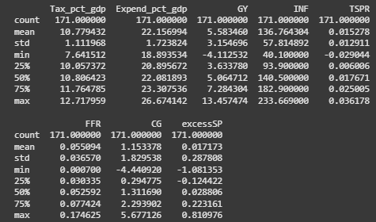

Feldstein (1982) has shown that only using the deficit can lead to ambiguous interpretations, since a deficit could result from a decrease in taxes or an increase in spending, which have differing implications for economic and asset returns. Including taxes and spending separately allows for a more meaningful interpretation of fiscal policy shocks. Following the approach of Tavares and Valkanov (2003), the variables capture the fiscal effects (Tax_pct_gdp, Expend_pct_gdp) and also the relationship of how fiscal policy can affect the real economy and financial markets (GY, INF, FFR).

To capture the ideological partisanship of fiscal policies, a classification of the variables is used which reflects both the macroeconomic context and redistribution effects, consistent with the literature on political economy and ideology. The following variables were used for ideology classification:

* UE: US unemployment rate, measured as a percentage of the labour force not currently employed, seasonally adjusted. (FRED)
* DF_pct_gdp: US defence spending (FRED), measured as a percentage change of GDP per quarter.
* FEDBUDGET: US federal government budget as a percentage of GDP. Showing the net spending between federal government receipts and expenditures relative to national output. (FRED)
* Prog_Top1: Annual change in progressivity for the top 1% of US citizens, computed through the annual change in progressivity index (Pre-tax share - Post-tax share). (Piketty et al.)
* Prog_Top10: Annual change in progressivity for the top 10% of US citizens, computed through the annual change in progressivity index. (Piketty et al.)
* Prog_Bottom50: Annual change in progressivity for the bottom 50% of US citizens, computed through the annual change in progressivity index. (Piketty et al.)
* Prog_Middle40: Annual change in progressivity for the middle 40% (30% to 70%) of US citizens, computed through the annual change in progressivity index. (Piketty et al.)

These variables are consistent with those used by Maddox et al. (1984). They define Liberal policy as being oriented towards the expansion of freedoms, whereas Conservative policy is more associated with fiscal restraint and the preservation of traditional structures. Applying this logic to fiscal policy, the overall budget spending (FEDBUDGET), unemployment rate (UE), and redistribution (Prog_Top, Prog_Top10, Prog_Bottom50, Prog_Middle40) are central to distinguishing between partisan regimes. These variables can be used to build upon a framework that distinguishes fiscal variables based on ideology using redistributive and economic context. If the classification performs as expected, the results will build upon Tavarez and Valkonov’s (2003) findings, and demonstrate if taxation and spending during Liberal and Conservative fiscal regimes generate different responses in the S&P 500.

## 3.3 Liberal and Conservative Classification

The classification of fiscal policies as Conservative or Liberal will inevitably involve approximations. The quality of data will be limited by the lack of computational energy, microdata availability, and the time required to research all taxation and spending policies to accurately classify each quarter. Therefore, to unbiasedly classify fiscal policies as Liberal or Conservative, a set of rules will need to be devised a priori based on predetermined literature.

As mentioned in the literature review, a general difference between Liberal and Conservative policies is that during periods of high unemployment, Liberal governments will increase their budget deficit, whereas Conservative governments will reduce the deficit stated by Persson (1995) and Cowart (1978 p432). Cusack (1999), used the previous year's unemployment rate as a measure of the lag in fiscal policy response, while Blinder (1988) used a rate of 5% as the borderline between low and high unemployment for the US. This provides the following concept: if unemployment (UE) exceeds 5% and the budget deficit increases (decreases), then the overall period could be classified as Liberal (Conservative). Therefore, if the unemployment rate is below 5% and the budget deficit increases (decreases) the period can be classified as Conservative (Liberal). This provides a general framework for classifying Liberal and Conservative fiscal policies. This is then applied to federal taxes and spending, then context is further applied to increase the robustness of the classification.

Bohn (2008), argued that warfare spending is inherently Conservative. Therefore, building on the general framework, if defence spending, as a percentage of GDP (DF_pct_gdp), increases during a period where government spending (Expend_pct_gdp) has been classified as Liberal, the classification will be changed to Conservative. This addition to the general framework allows contextual data to be added into the classification method for Federal spending, instead of relying solely on empirical data[7].

In the context of Federal Taxation (Tax_pct_gdp), the redistribution of income is a good proxy for classifying tax policies. Combining the themes discussed by Piketty et al. (2018), that 70% of the national income is through labour, and Andersson (2023) that Left wing tax policy is centred around redistribution, then the redistribution of labour can be used as a reasonable proxy for classifying Liberal and Conservative fiscal taxation. Thorsen (2016) proposed using non-behavioral microsimulation strategies, such as a fixed income approach. This method involves a fixed pretax income distribution, and is evaluated through changes in inequality indices such as the Gini, which is a measure of inequality as stated by Gastwirth (1972). This process provides a strong framework for classifying redistribution, and also prevents the pitfall of solely using the Gini index as alone it is a slow-moving measure of redistribution. Complimenting this Urban et al. (2008) highlighted that redistribution should also account for horizontal inequality, which measures the treatment of individuals with equivalent pre-tax incomes, and reranking, where the position of tax payers change after taxation. Their framework demonstrates that only relying on a vertical redistribution risks over-looking this empirically significant dimension of tax policy.

Using the method of Piketty et al. (2018), a proxy for identifying Conservative or Liberal taxes, which addresses vertical redistribution and does not rely on the Gini coefficient, can be developed. Unfortunately, it can not be used to account for horizontal redistribution, as this microsimulation approach requires microdata, which could not be accessed in this present study. Piketty provided data that could be used to obtain a pragmatic variable for redistribution (Prog_Top1, Prog_Top10, Prog_Bottom50, Prog_Middle40).

Piketty did not provide all the data, this will be discussed further in the limitations section. Using the data provided, Prog_Top1, Prog_Top10, Prog_Bottom50, and Prog_Middle40 are calculated as the annual change Pre-tax share - Post-tax share. The calculations are provided as follows:

Since the variables are based on yearly data this measures whether the distribution for each group has become more progressive or regressive per year. If the annual change for the bottom_50 and middle_40 are positive (negative), those groups got more progressive (regressive), due to more (less) income being transferred into lower income groups. On the other hand, if Top_1 and Top_10 are positive (negative), those groups got more regressive (progressive) due to less (more) of their income being redistributed into lower income groups. Using this data, the year of taxation is considered Liberal (Conservative) if three or more groups are progressive (regressive). If two of the groups are progressive and two of the groups are regressive, the fiscal taxation period is based on the overall period[8]. This method provides a solid proxy for ideological partisan taxation, weighing both the limitations and quality of results.

An overall fiscal regime is then calculated using the identified partisanship of Federal taxation and expenditures. If both taxes and spending are Liberal (Conservative), then the overall fiscal period is classified as Liberal (Conservative). If it is ambiguous, the overall period will be classified as Neutral. These three regimes (Liberal, Neutral, Conservative) can then be used exogenously within a VAR framework to obtain individual results per regime. The results per regime will allow a direct comparison between ideologically Conservative and Liberal fiscal regimes

## 3.4 Validation of Choices

This study uses quarterly US data on the S&P 500 spanning from 1971:1 to 2013:4, due Piketty et al. only having data availability up until 2013:4. This section will further explain the reasoning behind selecting the control variables, the estimation method, and the use of Impulse Response Functions (IRFs), Forecast Error Variance Decompositions (FEVDs) and Bootstrapping.

### 3.4.1 Control Variables

Within a VAR framework, it is necessary to distinguish between the variables of interest (Tax_pct_gdp and Expend_pct_gdp), the outcome variable (ExcessSP) and the control variables (INF, FFR and GY). The main model control variables consist of the inflation rate, federal funds rate, and the rate of per capita output growth (INF, FFR and GY). These variables are used in line with Tavarez and Valkanov (2003), who further explained and demonstrated their relevance to capturing macroeconomic dynamics. The output growth is a proxy for the business cycle and including this variable ensures that the estimated fiscal effect is simply just not picking up cyclical fluctuations. Controlling for inflation ensures that the effects captured by the fiscal variables are not due to inflation, which heavily affects asset prices and lastly controlling for the federal funds rate allows the VAR model to account for a monetary-fiscal policy interaction, which ensures that the importance of fiscal shocks is not amplified by FED actions. Incorporating these control variables is necessary to isolate the effect of partisan fiscal policies on the S&P 500.

Following Tavarez and Valkonov (2003) this study used the three key macroeconomic channels (inflation, federal funds rate and output growth) in order to avoid over-parameterisation. Using only these channels limits losing a large amount of degrees of freedom that comes from larger VAR systems.

### 3.4.2 Estimation Method

A pooled regression with Cholesky recursive identification and multiple exogenous regimes is employed as the estimation method. It is valid for this research as it combines the theoretical and practical implications of Tavarez and Valkanov (2003), Mundlak (1978) and Bai (2000). Tavarez and Valkonov (2003) applied Cholesky recursive identification to study how financial markets respond contemporaneously to federal taxes and spending policy changes, providing a model for studying stock market responses. Mundlak (1978) provided the econometric justification for using a pooled VAR for time-series analysis. He shows that pooling increases efficiency and brings consistent estimators when heterogeneity across regimes is properly accounted for. Bai (2000) modelled structural changes in VAR systems and proved that regime shifts in coefficients and covariance matrices can and should be implemented when analysing time-series subject to structural breaks.

Used in conjunction, these contribute to justify the use of a Pooled VAR with regime-specific variance-covariance structures and recursive identification, and allow this study to capture the effects of partisan fiscal shocks, while maintaining statistical validity and ensuring comparability with existing literature.

### 3.4.3 IRF, FEVD, and Bootstrapping: Results Validation

To validate the results found in the VAR model, Impulse Response Functions (IRFs), Forecast Error Variance Decompositions (FEVDs), and Bootstrapping methods are employed by this study.

The use of IRFs and FEVDs for results validation is widely found in classic VAR literature. It is employed by Tavarez and Valkanov (2003) as well as Lanne et al. (2014). They stated that IRFs and FEVDs are prominent tools, but require identification restrictions, such as incorporating Cholesky recursive ordering. These studies therefore further justify the use of IRFs and FEVDs for results validation in this study.

Bootstrapping is a prominent tool to generate confidence intervals for IRFs. Tavarez and Valkanov (2003) employed this method and used bootstrap confidence intervals (CIs) for IRF responses in their analysis of fiscal shocks and equity markets. Phillips et al. (2011) stated that it is common practice to use bootstrap confidence intervals for IRFs. They noted that there is a pitfall that comes with it as conventional bootstrap estimators of VAR error covariance matrices potentially distort CIs due to downward bias. While the bootstrap employed here is not flawless, it is a widely accepted method of inference and appropriate for quantifying uncertainty in a Pooled VAR with observable regime heterogeneity.

## 3.5 Methods of Estimation

As noted in the Literature review, multiple model frameworks could be applied to address this research objective. However, the pooled VAR framework was selected as the most appropriate, as it provided strong results in line with classical literature. The same framework is further applied across the robustness checks, each taking into account a different assumption.

This section explains the model estimation methodology starting with the stationarity tests. It further explains the Pooled VAR with Cholesky identification and the model specification.

### 3.5.1 Stationarity Tests

Before the variables can be put into a model, it must be ensured that all variables are stationary. This is because regressing non-stationary variables leads to misleading results as stated by Granger et al. (1974) and therefore non-stationary variables cannot be used. In the test the null hypothesis () is that the variables are not stationary

and the alternative hypothesis () is that the variables are stationary

.

Table 2 displays the results from the stationarity test and displays the results of an Autoregressive (AR)[9]Augmented Dickey-Fuller (ADF) and Phillips-Perron (PP) test in line with Tavarez and Valkonov (2003).

**Table 2: Results of the first stationarity test on all variables**

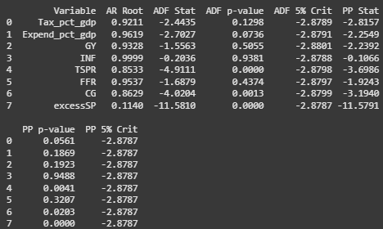

Table 2 reports the results of the ADF and PP tests for unit roots as well as the highest autoregressive root in the series. At a 10% significance level, most of the variables reject the null hypothesis () of a unit root for one or both tests, which confirms stationarity as the alternative hypothesis is accepted (). However, GY (growth output), INF (inflation) and FFR (federal funds rate) fail to reject both of the null hypothesis, as the p-value is greater than 0.1[10]. To ensure robustness, these variables were therefore differenced in line with the approach recommended by Granger et al. (1994). The transformed series were then used in the subsequent analysis and the results are shown in table 3.

**Table 3: Results of the differenced variables stationarity tests**

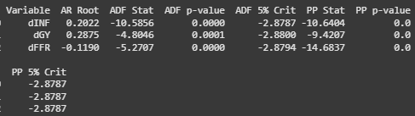

Table 3 shows that these values are now stationary at a 99% confidence interval as the p-value is less than 0.01, therefore the alternative hypotheses that these variables are stationary is accepted ().

### 3.5.2 Pooled VAR Model with Cholesky Identification

To study the effect of fiscal policy on S&P 500 returns whilst placing as few restrictions as possible on the dynamics, and following the approach of Tavarez and Valkanov (2003), the variables of interest are placed into a vector and are estimated under the following unrestricted system equation(1):

(1)

Where is a polynomial of degree and are unrestricted coefficient matrices, which capture the variables' dynamic interactions. The reduced form residuals are generally correlated with the covariance matrix .

The baseline VAR includes the fiscal, macroeconomic, and financial variables, shown in equation(2)

. (2)

Where denote the j-th selection row vector (1 in position j, 0 elsewhere). Then the j-th element of . ExcessSP is last in the order to allow market returns to react contemporaneously to the other shocks.

The model needs to be able to account for the fast-moving nature of asset prices. Edleberg et al. (1999) highlighted the timing issue of VAR models mismeasuring shocks due to markets reacting before the data is officially recorded. Tavarez and Valkanov (2003) acknowledged this problem, and instead of using Narrative approaches such as a Ramey-Shapiro approach, which Edelberg et al. incorporated. Tavarez et al. employed recursive contemporaneous restrictions using structural VAR identification with Cholesky ordering. This technique allows the fiscal variables (Tax_pct_gdp, Expend_pct_gdp) to adjust only with a lag, while market returns (ExcessSP) can respond contemporaneously due to being ordered last and allows the model to identify shocks directly. This is consistent with slow fiscal adjustment and fast financial markets, as within the particular quarter taxes (Tax_pct_gdp) and spending (Expend_pct_gdp) do not respond to changes in macroeconomic or financial variables, whilst returns (ExcessSP) can. If is the lower triangular Cholesky factor of , the structural shocks were obtained from .

Rather than estimating separate VARs per political regime and to maintain a full sample, the lag dynamics were pooled. The residual covariance, therefore, depends on the observed regime ,

,

Structural shocks were recovered period by period,

where is the Cholesky factor of .

The political regimes were implemented as exogenous labels within the model to select at each date and remain unchanged. The labels were then normalised to from the coded column (0, 1, 2).

### 3.5.3 Model Specification

To test the 6 hypotheses, the following baseline model was formulated:

. (Baseline Model)

## 3.6 Conclusion

The research design shows in detail how samples were obtained and classified, and gives an explanation of the variables and a justification for their use in this study, and it provides an in depth description of the pooled VAR with Cholesky recursive ordering.

# CHAPTER 4: RESULTS

## 4.1 Introduction

This chapter presents the main results from the pooled VAR model and robustness checks using forecast error variance decompositions (FEVDs), impulse response functions (IRFs) and bootstrapping for results validation and hypothesis testing. It starts with the results from the initial pooled VAR, which contain the retrospective FEVDs and IRFs of the spending and taxation shocks during Conservative and Liberal regimes. The results of the robustness checks are then explained, which involve testing different lag lengths in line with Ozcicek et al. (1999), to ensure results stay consistent. Control variables were added, and reordering the variables robustness checks were carried out in line with the approach of Tavarez and Valkanov (2003). This ensures that the effect of omitted variables or incorrect economic assumptions was not captured by the model.

It should be noted that although Conservative, Liberal and Neutral fiscal regimes are used in the modelling, the Neutral regime results are omitted in this discussion. This is because the purpose of the study was to compare the effects of Conservative and Liberal ideological fiscal policy regimes. Therefore the study focused on testing strictly Conservative and Liberal policies against each other.

## 4.2 Results from the Pooled VAR model

The following figures and table show the results from the pooled VAR baseline model. Figure 1 illustrates the response of the S&P 500 during Conservative and Liberal regimes, and Figure 2 displays the response to a taxation shock during the same regimes. The IRFs are paired with the FEVDs, for both Liberal and Conservative periods and displayed in Table 4.

**Figure 1: Shows the IRF of the effect to S&P 500 returns after a spending shock during both regimes using the baseline model**

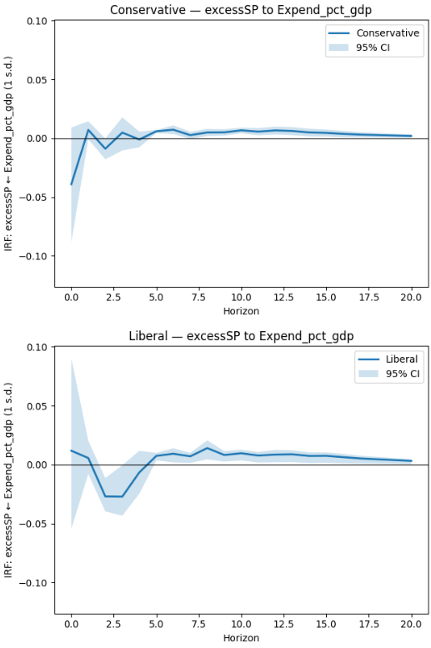

**Figure 2: Shows the IRF of the effect to S&P 500 returns after a tax shock during both regimes using the baseline model**

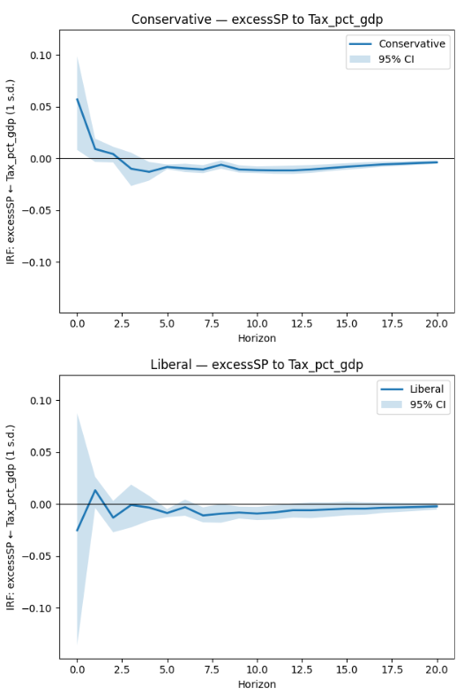

**Table 4: Shows the FEVD response of S&P 500 returns during both regimes using the baseline model**

-----------------------------------------------------------------------

FEVD (%) — Conservative | Response: excessSP

Tax_pct_gdp Expend_pct_gdp dGY dINF dFFR excessSP Sum_%

H=1 7.00 3.31 0.28 6.11 0.32 82.98 100.00

H=4 6.81 3.17 2.95 10.11 1.53 75.44 100.01

H=8 7.27 3.33 3.08 10.36 1.53 74.44 100.01

H=12 8.05 3.53 3.03 10.42 1.52 73.46 100.01

H=16 8.47 3.64 2.99 10.75 1.50 72.66 100.01

H=20 8.58 3.67 2.98 10.89 1.49 72.39 100.00

-----------------------------------------------------------------------

-----------------------------------------------------------------------

FEVD (%) — Liberal | Response: excessSP

Tax_pct_gdp Expend_pct_gdp dGY dINF dFFR excessSP Sum_%

H=1 1.79 0.38 2.56 5.35 22.68 67.23 99.99

H=4 1.96 3.27 5.92 6.53 21.51 60.81 100.00

H=8 2.48 3.95 6.06 6.61 21.13 59.77 100.00

H=12 2.91 4.44 5.99 6.64 20.83 59.18 99.99

H=16 3.06 4.81 5.91 6.83 20.69 58.70 100.00

H=20 3.11 4.92 5.89 6.92 20.65 58.52 100.01

-----------------------------------------------------------------------

Figure 1 displays the IRFs of the S&P 500 to government spending shocks under ideologically Conservative and Liberal fiscal regimes up to 20 Horizons (5 years). Under Conservative regimes the response of the S&P 500 to spending shocks after being initially negative, is generally positive but close to 0 across all Horizons. However, spending shocks during Liberal regimes have an immediate positive response, turning strongly negative in the short term but then stabilising to a small positive effect over mid- and long-term horizons. Table 4 reports the FEVDs under both regimes. Under fiscally Conservative regimes, spending (Expend_pct_gdp) accounts for approximately 3.3% of the variation in the S&P 500 across all horizons up to 20 quarters (5 years). For fiscally Liberal regimes, spending accounts for less than 1% of the variation in the S&P 500 initially but increases to almost 5% by Horizon 20.

Figure 2 displays the IRFs of the S&P 500 to government taxation under ideologically Conservative and Liberal fiscal regimes up to 20 Horizons (5 years). Under Conservative regimes, the S&P 500 has an initial positive response to taxation shocks, before a mid- to long- term negative response which converges to 0. In Liberal regimes, the response fluctuates around 0 before converging to 0 from a negative mid-term response. Table 4 shows under Conservative regimes, taxation (Tax_pct_gdp) explains approximately 7 to 8% of the S&P 500 variation, whereas during Liberal regimes at Horizon 1 it explains slightly less than 2% and increases to just above 3% by Horizon 20.

## 4.3 Robustness Checks

To validate the model, a series of robustness checks were carried out. This section examines the stability of the results using FEVDs and IRFs under alternative model specifications, specifically, changes in the lag length (3 and 5 lags), including additional variables and altering the order of the variables in line with Tavarez & Valkanov (2003).

### 4.3.1 Additional Variables Robustness Check

The consumption growth (GC) and the term spread (TSPR), are incorporated as alternative control variables. This tests the robustness by ensuring the results found are not driven by correlations with omitted variables. Figure 3 displays the IRF of the S&P 500 in response to government spending under Conservative and Liberal fiscal regimes, Figure 4 shows the responseto government taxation and Table 5 presents the FEVDs all after the incorporation of additional variables.

**Figure 3: Shows the IRF of the effect to S&P 500 returns after a spending shock during both regimes using the additional variables robustness check**

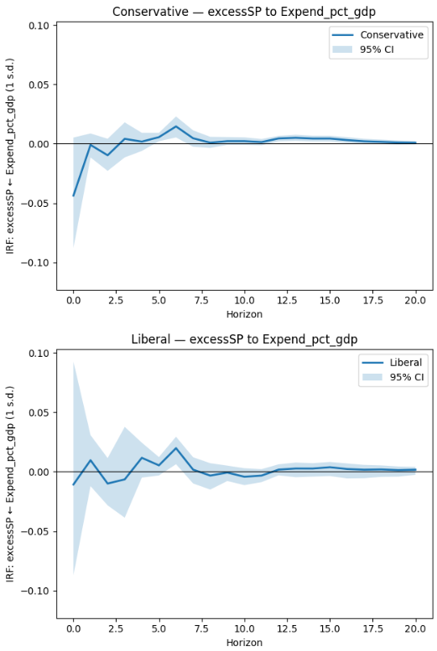

**Figure 4: Shows the IRF of the effect to S&P 500 returns after a tax shock during both regimes using the additional variables robustness check**

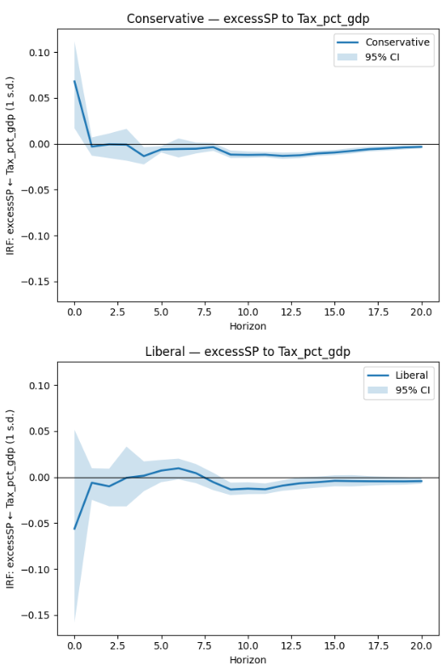

**Table 5: Shows the FEVD response of S&P 500 returns during both regimes using the additional variables robustness check**

----------------------------------------------------------------------------------------

FEVD (%) — Conservative | Response: excessSP

Tax_pct_gdp Expend_pct_gdp dGY CG dINF dFFR TSPR excessSP Sum_%

H=1 9.97 4.11 0.49 5.47 1.60 0.21 8.23 69.90 99.98

H=4 8.80 3.70 4.15 7.01 3.50 1.42 11.19 60.23 100.00

H=8 8.53 3.97 4.13 7.55 4.29 1.52 12.65 57.35 99.99

H=12 9.35 3.93 4.06 7.96 4.29 1.53 12.56 56.31 99.99

H=16 9.90 4.00 4.04 7.92 4.35 1.60 12.40 55.79 100.00

H=20 9.98 3.99 4.18 7.88 4.41 1.63 12.36 55.58 100.01

----------------------------------------------------------------------------------------

----------------------------------------------------------------------------------------

FEVD (%) — Liberal | Response: excessSP

Tax_pct_gdp Expend_pct_gdp dGY CG dINF dFFR TSPR excessSP Sum_%

H=1 6.95 0.46 2.08 9.52 2.67 19.51 1.92 56.89 100.00

H=4 5.85 0.87 8.55 13.28 2.96 17.06 4.37 47.06 100.00

H=8 5.92 1.56 8.56 14.31 2.99 16.47 4.99 45.19 99.99

H=12 6.78 1.58 8.43 14.75 2.95 16.19 4.94 44.37 99.99

H=16 6.89 1.62 8.40 14.70 3.05 16.26 4.97 44.11 100.00

H=20 6.97 1.63 8.50 14.62 3.11 16.25 4.99 43.93 100.00

----------------------------------------------------------------------------------------

Figure 3 and Figure 4 shows that when CG and TSPR are included the results present similar characteristics as the results without their incorporation (baseline model). With respect to US Government spending, a Conservative regime presents a weak positive effect in the medium to long-term. US Government spending under a Liberal regime presents marginally different findings to the baseline model. In the short term there are negative to positive effect swings with a weaker statistical significance, and the long term effect fluctuates but remains close to 0. Taxation in a Conservative fiscal regime shows an initial positive effect, which converges close to 0 by Horizon 20 after a mid- and long- term negative effect. While a Liberal regime displays a short-term negative effect that converges towards zero at longer horizons.

Table 5 displays the FEVDs, which show a slightly higher proportion of the S&P 500 variation is explained by government spending (Expend_pct_gdp) and taxation (Tax_pct_gdp) than in the baseline model. For a fiscally Conservative regime taxes account for approximately 2% more and spending accounts for approximately 0.4% more than in the baseline model. For a fiscally Liberal regime taxes account for approximately 3% more and spending accounts for approximately 0.7% less until Horizon 8.

Ultimately, these results show a broad consistency with the baseline model, indicating that including these variables do not substantially alter the main findings.

### 4.3.2 Lags Robustness Checks

As part of the robustness checks, the lag length of the VAR was varied to test the model with three lags and then with five lags. This was to ensure the dynamic structure of the data was accurately captured and the baseline model using four lags was not driving the results. This is consistent with the approach of Ozcicek et al. (1999). They reiterated Lütkepohl’s (1993) argument that selecting too high a number of lags can lead to overfitting, but not enough lags could generate autocorrelation errors. The IRFs (Figure 5, Figure 6, Figure 7, Figure 8) and FEVDs (Table 6, Table 7) are reported in Appendix 1. With three lags used in the model the main characteristics of the baseline model were mirrored. The FEVD also remains consistent to the baseline model with little difference.

However, with five lags used in the model, different results were found as can be seen in the IRFs and FEVDs for this model, which are reported in Appendix 1. Considering the effects of US Government spending, both Conservative and Liberal fiscal regimes display an initial negative effect followed by a mid- to long- term positive effect, which converges to 0. Considering the effects of US Government taxation, both Conservative and Liberal fiscal regimes display a short term positive effect, followed by a mid- to long-term negative effect, which converges to 0. The FEVDs display a higher explanatory power from the baseline model as well, especially in Liberal regimes. Both taxation and spending explain 9% of the variation in the S&P 500 returns by Horizon 20, which is approximately 4.5% higher than in the baseline model. Whereas for spending and taxation during a Conservative fiscal regime the explanatory power increases by approximately 1%.

These findings show that the model with three lags supports the reliability of the baseline model, whereas the findings of the model with five lags shows a different picture. This difference could be caused by longer run dynamics being overfit or picking up more noise, which leads to the apparent increased explanatory power of the fiscal variables. This suggests that the baseline model using four lags is appropriate and this keeps the current study consistent with that of Ozcicek et al..

### 4.3.3 Reordering Robustness Check

The following robustness check consists of a reordering of taxation and spending to further validate the results. Tavarez and Valkanov (2003) used this robustness check, since government spending was originally ordered before taxation in the baseline model. This enforces the economic assumption that taxation can respond contemporaneously to spending and not the other way around. Therefore swapping these variables ensures that the ordering of these two variables does not change the results. The FEVDs (Figure 9, Figure 10) and IRFs (Table 8) have been reported in Appendix 1. The figures show an almost identical result to the baseline model, the FEVDs were very similar for Liberal regimes but varied marginally for Conservative regimes. Tax shocks were lower by 2% on average and spending shocks were higher by approximately 3% in explaining S&P 500 returns.

# 

# CHAPTER 5: DISCUSSION AND CONCLUSION

## 5.1 Introduction

This chapter discusses the results and is structured into four sections. The first will be the interpretation of the empirical results with relation to the study hypotheses. Next it will further examine what this implies and where it sits alongside existing literature. It will highlight where the findings agree with prior literature and where they diverge from this, and what this may suggest about the relationship between fiscal policy regimes and equity markets. The following section will discuss the limitations of the current research, followed by a consideration of approaches which could be taken for future research, and lastly, a conclusion of the whole study.

## 5.2 Study Hypotheses

With relation to the study hypotheses, first focussing on the Conservative Regime Hypotheses (2.5.1) and the Liberal Regime Hypotheses (2.5.2), during both regimes it was found that the effects of taxation and spending on the S&P 500 returns were statistically significant at specific horizons. This means the null hypotheses ( & & & ) are rejected and the alternative hypotheses ( & ) are accepted for all four. Looking at Figure 1 and Figure 2, for spending, the Conservative regime had a positive and statistically significant effect from Horizon 4 to 20 (1 to 5 years), whereas the Liberal regime had an initially negative and statistically significant effect at Horizon 2 (6-months) then a positive and statistically significant effect from Horizon 4 to 20 (1 to 5 years). For taxation, the Conservative regime had an initially positive and statistically significant effect at Horizon 0. It then showed a negative and significant effect from Horizon 4 to 20. Liberal regime taxation had an ambiguous characteristic and did not show a consistently negative effect until Horizon 4 and the results were not as clear as during a Conservative regime. There was a weak correlation between spending during a Liberal fiscal regime and the S&P 500 returns.

The last hypothesis is whether Conservative and Liberal fiscal policy instruments, spending and taxation, have opposing effects on the S&P 500 returns. Looking at the same figures and Table 4 the evidence suggests the orientation of fiscal policies do matter. US taxation shocks during a Conservative fiscal regime display a more persistent negative relationship with returns, whereas US expenditure during a Liberal regime initially lowers returns before showing a positive effect at longer horizons. In contrast, the Conservative spending effect is more stable and shows a positive effect at longer periods, whilst the Liberal taxation effect is ambiguous and the significance was weaker. The results imply that we should reject the null hypothesis () and accept the alternative hypothesis (), as there is evidence in this study that the ideological orientation of fiscal policies does have differing effects on the S&P 500 returns.

## 5.3 What do the Results Imply

The findings diverge from those of Tavarez and Valkanov (2003), as they reported weak and largely insignificant effects of government spending on S&P 500 returns, hypothesising it may be due to a poor link to growth. The stronger significance found in this study may be due to separating spending and taxation shocks into partisan ideology. Through disaggregating US taxation and spending into Conservative and Liberal fiscal regimes, short term differences emerge, which are not seen in aggregate models, particularly up to 4 horizons (1 year). The effect of Conservative spending up to one year is largely ambiguous, whereas Liberal spending showed a negative response. This may be due to investor uncertainty around the sustainability of Liberal spending policies. Chatziantoniou et al. (2013) stated that expansionary fiscal policies could generate a short-run crowding out effect due to inflation and higher borrowing costs. There could be investor concerns in the short run due to Liberal spending. However in the long run the effects seem to dissipate, and stay consistent with the Keynesian argument that fiscal policies can stimulate aggregate demand as Giorgioni et al. (2003) and Chatziantoniou et al.(2013) argued.

Conservative spending displays a positive long-run effect, which could be due to markets interpreting Conservative spending as methodological or disciplined, and so less inflationary. This would align with Cusack (1999) and Persson et al. (1995), who supported the idea that Conservative fiscal policy is associated with restraint. In contrast, the initial negative response to Liberal regimes, followed by a long-term positive response, shows that markets may not have the same initial belief that Liberal spending will be able to continue, but the fact it converges to a positive association may argue that it stimulates the same growth.

Focussing on the tax effects, the initially positive effect of Conservative regime tax shocks on the S&P 500 returns may reflect that Conservative tax shocks potentially favour businesses, therefore boosting short term profits. However, the longer term effect is unstable as the IRF shows a negative effect on the S&P 500 returns at longer horizons, staying similar to the response of the S&P 500 to a tax shock during a Liberal regime.

The FEVDs provided further support for the idea that the ideological orientation of fiscal policy influenced how markets process fiscal shocks. In the baseline model, S&P 500 returns in Conservative regimes are driven mainly by tax shocks (7 to 9%) with lower spending shock effects (3 to 4%), while Liberal fiscal regimes have a weaker effect (tax shocks = 2 to 3%, spending shocks = 1 to 5%) with a stronger effect coming from monetary policy (20 to 23%) on S&P 500 returns. The robustness check with the inclusion of GC and TSPR confirm this, with the effects of taxes in both regimes rising slightly (2 to 3%) and the effects of spending stayed similar. This aligned with the findings of Tavarez and Valkanov (2003) as it showed fiscal shocks do matter in both Conservative and Liberal fiscal regimes but have more of an influence in Conservative regimes, whereas explanatory power shifts to monetary policy in Liberal regimes.

Overall, the findings did agree with the findings and conclusions of Tavarez and Valkanov (2003) who found that taxation shocks had an overall negative effect on the S&P 500 returns. With regards to spending shocks, this current study agreed with the studies of others in finding that spending shocks caused a positive effect on the stock market. Lastly, Tavarez and Valkonov (2003) concluded that the lack of spending shock statistical significance may be due to the aggregation of fiscal partisan orientations, and once separated, more unique patterns could emerge. This study builds on their conclusion and shows that the partisan fiscal ideology can be seen to have played a crucial role in determining stock market returns.

## 5.4 Limitations

The first issue is the timing issue, markets react quickly and financial markets can factor the information in before the data is released as discussed by Tavarez and Valkanov (2003, p12). This could have been solved with a Narrative VAR by introducing exact announcement dates, but this would have required large amounts of time to find the data for each fiscal policy, which is not possible. This study therefore incorporates Cholesky recursive identification to allow for markets reacting quickly to the fiscal policies, but this is not perfect. If the markets reacted before the quarter starts, the effects of the shock will be missed.

The availability of data is also another problem. An issue arose for measuring tax redistribution as the micro-data was unattainable. Therefore, a compromise was to use the data for measuring redistribution provided by the Piketty et al. study. However, this data was measured yearly and removed the top 0.1% and 0.01% of earners, which Piketty et al. stated is the most important information to measure redistribution. This current study had to incorporate the yearly data into a quarterly format by creating a comparison with the overall fiscal deficit, and it left out the most important data points for measuring redistribution. The omission of these data points means that the redistribution measure for taxes could lead to inaccuracies.

## 5.5 Recommendations for Further Research

There were several challenges faced by this research. One challenge relates to the timing of fiscal policy announcements and when the market reacts. Future research could attempt to find exact dates for fiscal policies announcements or use event study methodologies, allowing for a more accurate identification of market responses.

Another limitation was the data availability as Piketty et al. (2007) only had data up until 2013 and this contained gaps, such as the omission of the top earners categories. Expanding the dataset to more recent observations would improve the statistical power. Additionally, incorporating the top 0.1% and 0.01% of income redistribution measures could add important insights into the ideological partisan orientation of government taxation, contributing to a more robust conclusion.

This research also presents clear opportunities for a further extension of the framework. It presents a template for comparing the ideological composition of partisan fiscal policies and testing their effects on financial markets. The same framework could be applied to other asset classes such as, government bonds, corporate bonds or other ETFs. This might assess whether fiscal ideology produces consistent or differing effects across markets. By expanding this research across other asset classes and incorporating more robust data sets, future research could provide a more comprehensive visualisation of how fiscal policy ideological orientations can shape financial outcomes.

## 5.6 Conclusion

This study aimed to identify government policy as Conservative or Liberal, separate from party affiliation, and test whether the ideological orientation of fiscal policies, Conservative or Liberal, had different effects on the S&P 500 returns. Within a Conservative fiscal policy regime, the effects of taxation were significant, initially positive and then negative and the effects of spending were stable and positive in the long run. For a Liberal regime, spending effects were initially negative then positive in the long run and tax effects had a weaker influence on S&P 500 returns. The FEVDs showed that fiscal shocks do matter, and were stronger in a Conservative fiscal regime, while in a Liberal fiscal regime monetary policy (Federal Funds Rate) tends to dominate.

The results found here support the findings of Tavarez and Valkanov (2003) by displaying that a disaggregated view of fiscal policy, through identifying the partisan ideology could matter, and that prior studies tend to overlook the fact that the ideological orientation of fiscal policies can have an influence on stock market behaviour.

The research carried out also contributes to the classification of fiscal policies into ideological regimes testing the effects of these on asset market returns. It demonstrates that separating fiscal policy by ideology provides a deeper insight into asset market response. Investors and policymakers should be aware of fiscal ideological orientation when assessing market responses. However it is acknowledged that the study did have some limitations such as the effect of the timing of announcements and data availability. This research could be extended to consideration of other asset markets such as corporate and government bonds or to international comparability studies.

To conclude, this dissertation demonstrated that the ideological orientation of fiscal policies could be significant when accounting for the effects on financial market returns. Both Conservative tax shocks and Liberal spending shocks produce unique dynamics. By focusing on this ideological orientation rather than government party affiliation, this study contributes to understanding how fiscal decisions shape asset prices.

# 

# BIBLIOGRAPHY

Agnello, L. and Sousa, R.M. (2011). Fiscal Policy and Asset Prices. *Bulletin of Economic Research*, [online] 65(2), pp.154–177. doi:https://doi.org/10.1111/j.0307-3378.2011.00420.x.

Alesina, A., Stantcheva, S. and Teso, E. (2018). Intergenerational Mobility and Preferences for Redistribution. *American Economic Review*, 108(2), pp.521–554. doi:https://doi.org/10.1257/aer.20162015.

Andersson, P. (2023). *Ideology and Redistribution: Left-wing Tax policy 1870-1945*. [online] Available at: https://www.perfandersson.com/uploads/1/2/7/5/127505228/andersson_2023_apsa_2.pdf [Accessed 17 Sep. 2025].

Bai, J. (2000). *Vector Autoregressive Models with Structural Changes in Regression Coefficients and in Variance-Covariance Matrices*. [online] CEMA Working Papers. Available at: https://ideas.repec.org/p/cuf/wpaper/24.html [Accessed 17 Sep. 2025].

Barnes, L. (2014). The size and shape of government: preferences over redistributive tax policy. *Socio-Economic Review*, 13(1), pp.55–78. doi:https://doi.org/10.1093/ser/mwu007.

Blinder, A.S. (1988). *The Challenge of High Unemployment*. [online] National Bureau of Economic Research. doi:https://doi.org/10.3386/w2489.

Bohn, H. (2008). *Sustainability of Public Debt*. [online] Google Books. Available at: https://books.google.com/books?hl=en&lr=&id=0_5CKzOxD7kC&oi=fnd&pg=PA15&dq=the+sustainability+of+fiscal+policy&ots=ZuV7EUNfF_&sig=leOJKXLmaGZMRzS38Th64SY5idM [Accessed 17 Sep. 2025].

Bybee, L., Kelly, B. and Su, Y. (2023). Narrative Asset Pricing: Interpretable Systematic Risk Factors from News Text. *Review of Financial Studies*, 36(12), pp.4759–4787. doi:https://doi.org/10.1093/rfs/hhad042.

Chatziantoniou, I., Duffy, D. and Filis, G. (2013). Stock market response to monetary and fiscal policy shocks: Multi-country evidence. *Economic Modelling*, [online] 30, pp.754–769. doi:https://doi.org/10.1016/j.econmod.2012.10.005.

Cowart, A.T. (1978). The Economic Policies of European Governments, Part II: Fiscal Policy. *British Journal of Political Science*, 8(4), pp.425–439. doi:https://doi.org/10.1017/s0007123400001484.

CUSACK, T.R. (1999). Partisan Politics and Fiscal Policy. *Comparative Political Studies*, 32(4), pp.464–486. doi:https://doi.org/10.1177/0010414099032004003.

Darrat, A.F. (1988). On Fiscal Policy and the Stock Market. *Journal of Money, Credit and Banking*, [online] 20(3), pp.353–363. doi:https://doi.org/10.2307/1992261.

Edelberg, W., Eichenbaum, M. and Fisher, J.D.M. (1999). Understanding the Effects of a Shock to Government Purchases. *Review of Economic Dynamics*, 2(1), pp.166–206. doi:https://doi.org/10.1006/redy.1998.0036.

Ehrmann, M., Ellison, M. and Valla, N. (2003). Regime-dependent impulse response functions in a Markov-switching vector autoregression model. *Economics Letters*, [online] 78(3), pp.295–299. doi:https://doi.org/10.1016/S0165-1765(02)00256-2.

Feldstein, M. (1982). Government deficits and aggregate demand. *Journal of Monetary Economics*, 9(1), pp.1–20. doi:https://doi.org/10.1016/0304-3932(82)90047-2.

Gastwirth, J.L. (1972). The Estimation of the Lorenz Curve and Gini Index. *The Review of Economics and Statistics*, 54(3), p.306. doi:https://doi.org/10.2307/1937992.

Giorgioni, G. and Holden, K. (2003). Ricardian equivalence, expansionary fiscal contraction and the stock market: a VECM approach. *Applied Economics*, 35(12), pp.1435–1443. doi:https://doi.org/10.1080/0003684032000125088.

Granger, C.W.J. and Newbold, P. (1974). Spurious regressions in econometrics. *Journal of Econometrics*, 2(2), pp.111–120. doi:https://doi.org/10.1016/0304-4076(74)90034-7.

H.E.T. Holgersson, L. Nordström and Ö. Öner (2013). Dummy variables vs. category-wise models. *Journal of Applied Statistics*, 41(2), pp.233–241. doi:https://doi.org/10.1080/02664763.2013.838665.

Hardy, M. (2025). *Regression with Dummy Variables*. [online] Google Books. Available at: https://books.google.com/books?hl=en&lr=&id=EzLffJlYISEC&oi=fnd&pg=PP7&dq=dummy+variables+to+measure+quantitative&ots=RbpXbYvfNw&sig=zJ0WCXWNtDJI2537uXLgBplkI5Y [Accessed 17 Sep. 2025].

Herring, E.P. (1938). The Politics of Fiscal Policy. *The Yale Law Journal*, 47(5), p.724. doi:https://doi.org/10.2307/791990.

ikram, sana (2012). *Testing Semi-Strong Form of Efficient Market Hypothesis in Relation to the Impact of Foreign Institutional Investors’ (FII’s) Investments on Indian Capital Market*. [online] Academia.edu. Available at: https://www.academia.edu/download/7669708/second_paper.pdf [Accessed 17 Sep. 2025].

Jacobson, G.C. (2016). Polarization, Gridlock, and Presidential Campaign Politics in 2016. *The ANNALS of the American Academy of Political and Social Science*, 667(1), pp.226–246. doi:https://doi.org/10.1177/0002716216658921.

Jeselius, K. (n.d.). *The Cointegrated VAR Model*. [online] Google Books. Available at: https://books.google.com/books?hl=en&lr=&id=fNESDAAAQBAJ&oi=fnd&pg=PR7&dq=VAR+model&ots=gHgzUZIrQG&sig=O2LamI9JxFQ7yLDeojJJiwhXZKc [Accessed 17 Sep. 2025].

Jordà, Ò. (2005). Estimation and Inference of Impulse Responses by Local Projections. *American Economic Review*, 95(1), pp.161–182. doi:https://doi.org/10.1257/0002828053828518.

Lanne, M. and Nyberg, H. (2016). Generalized Forecast Error Variance Decomposition for Linear and Nonlinear Multivariate Models. *Oxford Bulletin of Economics and Statistics*, 78(4), pp.595–603. doi:https://doi.org/10.1111/obes.12125.

Laopodis, N.T. (2009). Fiscal policy and stock market efficiency: Evidence for the United States. *The Quarterly Review of Economics and Finance*, 49(2), pp.633–650. doi:https://doi.org/10.1016/j.qref.2007.10.004.

Maddox, W. (2025). *Beyond Liberal and Conservative*. [online] Google Books. Available at: https://books.google.com/books?hl=en&lr=&id=3_GdfKGni28C&oi=fnd&pg=PP2&dq=beyond+liberal+and+conservative&ots=YOM2DSGOgk&sig=exiQsQwVY5UGfYOrs5g-UuyNnAE [Accessed 17 Sep. 2025].

Mundlak, Y. (1978). On the Pooling of Time Series and Cross Section Data. *Econometrica*, 46(1), p.69. doi:https://doi.org/10.2307/1913646.

OZCICEK, O. and DOUGLAS McMILLIN, W. (1999). Lag length selection in vector autoregressive models: symmetric and asymmetric lags. *Applied Economics*, 31(4), pp.517–524. doi:https://doi.org/10.1080/000368499324237.

Persson, T. and Tabellini, G. eds., (1995). *Monetary and Fiscal Policy: Politics*. [online] Google Books. Available at: https://books.google.com/books?hl=en&lr=&id=1YdzMC6dPhkC&oi=fnd&pg=PA1&dq=what+makes+a+left+and+right+fiscal+policy&ots=P34QR-GL6s&sig=YwbMNqW-YCd_hhtOm_SJPFyEdyU [Accessed 17 Sep. 2025].

Phillips, K.L. and Spencer, D.E. (2011). Bootstrapping structural VARs: Avoiding a potential bias in confidence intervals for impulse response functions. *Journal of Macroeconomics*, 33(4), pp.582–594. doi:https://doi.org/10.1016/j.jmacro.2011.02.007.

Piketty, T. and Saez, E. (2006). *How Progressive is the U.S. Federal Tax System? A Historical and International Perspective*. [online] doi:https://doi.org/10.3386/w12404.

Potrafke, N. (2017). Government ideology and economic policy-making in the United States—a survey. *Public Choice*, 174(1-2), pp.145–207. doi:https://doi.org/10.1007/s11127-017-0491-3.

Rudolph, T.J. (2009). Political Trust, Ideology, and Public Support for Tax Cuts. *Public Opinion Quarterly*, 73(1), pp.144–158. doi:https://doi.org/10.1093/poq/nfp012.

Santa-Clara, P. and Valkanov, R. (2003). The Presidential Puzzle: Political Cycles and the Stock Market. *The Journal of Finance*, [online] 58(5), pp.1841–1872. doi:https://doi.org/10.1111/1540-6261.00590.

Schepers, J. (2015). On regression modelling with dummy variables versus separate regressions per group: Comment on Holgerssonet al. *Journal of Applied Statistics*, 43(4), pp.674–681. doi:https://doi.org/10.1080/02664763.2015.1077371.

Tavares, J. and Rossen Valkanov (2005). Fiscal Policy and Asset Returns.

Thoresen, T.O., Jia, Z. and Lambert, P.J. (2016). Is there More Redistribution Now? A Review of Methods for Evaluating Tax Redistributional Effects. *FinanzArchiv / Public Finance Analysis*, [online] 72(3), pp.302–333. doi:https://doi.org/10.2307/24807497.

Tobin, J. (1969). A General Equilibrium Approach to Monetary Theory. *Journal of Money, Credit and Banking*, [online] 1(1), pp.15–29. doi:https://doi.org/10.2307/1991374.

Urban, I. and Lambert, P.J. (2008). Redistribution, Horizontal Inequity, and Reranking. *Public Finance Review*, 36(5), pp.563–587. doi:<https://doi.org/10.1177/1091142107308295>.

Wong, W.-K. and McAleer, M. (2009). Mapping the Presidential Election Cycle in US stock markets. *Mathematics and Computers in Simulation*, 79(11), pp.3267–3277. doi:<https://doi.org/10.1016/j.matcom.2009.05.007>.

**APPENDIX 1**

**Figure 5: Shows the IRF of the effect to S&P 500 returns after a spending shock during both regimes using the three lags robustness check**

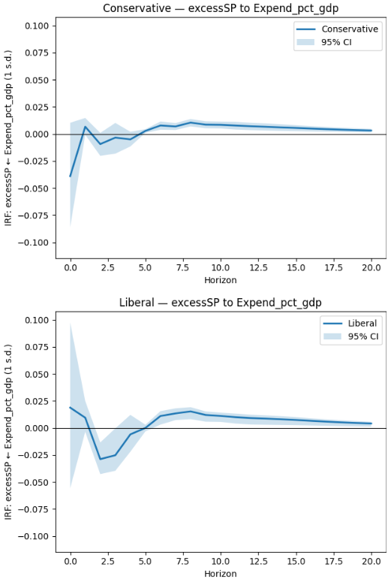

**Figure 6: Shows the IRF of the effect to S&P 500 returns after a tax shock during both regimes using the three lags robustness check**

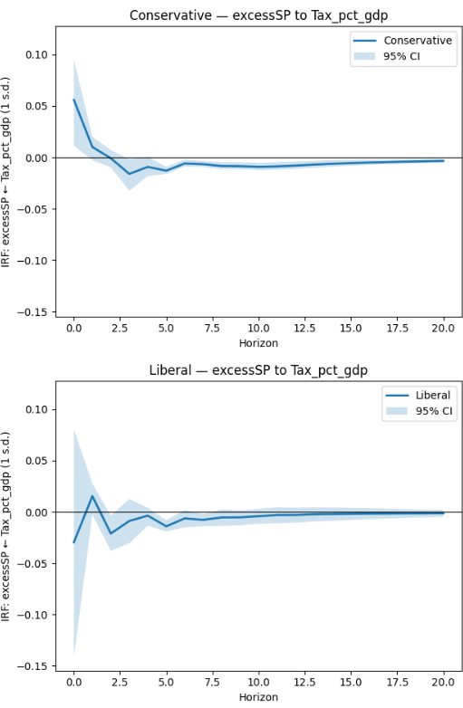

**Table 6: Shows the FEVD response of S&P 500 returns during both regimes using the three lags robustness check**

-----------------------------------------------------------------------

FEVD (%) — Conservative | Response: excessSP

Tax_pct_gdp Expend_pct_gdp dGY dINF dFFR excessSP Sum_%

H=1 6.82 3.30 0.92 7.26 0.29 81.42 100.01

H=4 6.70 3.17 3.69 11.38 1.56 73.50 100.00

H=8 7.16 3.53 3.71 11.38 1.63 72.59 100.00

H=12 7.58 3.93 3.66 11.63 1.61 71.60 100.01

H=16 7.75 4.12 3.62 11.93 1.59 70.98 99.99

H=20 7.82 4.21 3.61 12.07 1.58 70.71 100.00

-----------------------------------------------------------------------

-----------------------------------------------------------------------

FEVD (%) — Liberal | Response: excessSP

Tax_pct_gdp Expend_pct_gdp dGY dINF dFFR excessSP Sum_%

H=1 2.39 0.95 0.67 4.37 22.21 69.40 99.99

H=4 3.12 3.68 5.04 5.15 20.77 62.23 99.99

H=8 3.66 4.60 5.09 5.09 20.37 61.21 100.02

H=12 3.72 5.35 5.02 5.18 20.13 60.60 100.00

H=16 3.72 5.74 4.99 5.32 20.03 60.22 100.02

H=20 3.72 5.89 4.97 5.38 19.99 60.05 100.00

-----------------------------------------------------------------------

**Figure 7: Shows the IRF of the effect to S&P 500 returns after a spending shock during both regimes using the five lags robustness check**

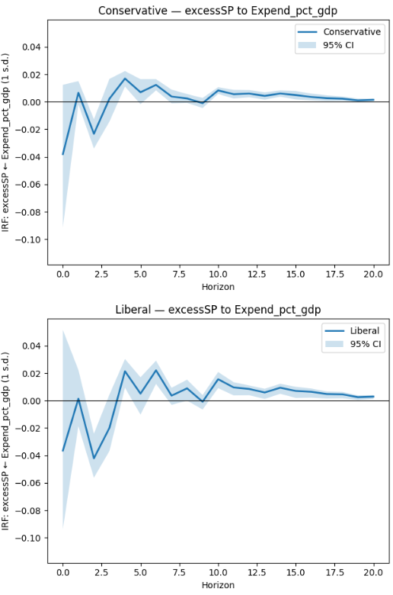

**Figure 8: Shows the IRF of the effect to S&P 500 returns after a tax shock during both regimes using the five lags robustness check**

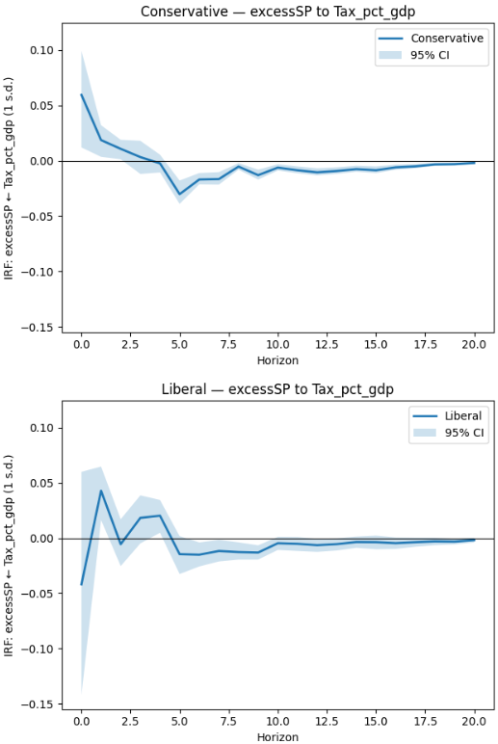

**Table 7: Shows the FEVD response of S&P 500 returns during both regimes using the five lags robustness check**

-----------------------------------------------------------------------

FEVD (%) — Conservative | Response: excessSP

Tax_pct_gdp Expend_pct_gdp dGY dINF dFFR excessSP Sum_%

H=1 7.88 3.03 1.23 3.48 0.73 83.65 100.00

H=4 7.20 4.18 3.36 8.22 1.77 75.27 100.00

H=8 9.29 4.29 3.51 8.59 1.76 72.55 99.99

H=12 9.79 4.45 3.47 8.71 1.83 71.75 100.00

H=16 10.10 4.55 3.44 8.87 1.82 71.22 100.00

H=20 10.15 4.56 3.45 8.97 1.82 71.05 100.00

-----------------------------------------------------------------------

-----------------------------------------------------------------------

FEVD (%) — Liberal | Response: excessSP (quick view)

Tax_pct_gdp Expend_pct_gdp dGY dINF dFFR excessSP Sum_%

H=1 7.82 2.91 1.77 9.93 14.68 62.89 100.00

H=4 8.28 7.52 3.62 10.74 14.15 55.70 100.01

H=8 9.17 8.21 3.88 10.88 13.61 54.25 100.00

H=12 9.48 8.79 3.83 10.84 13.47 53.60 100.01

H=16 9.53 9.08 3.81 10.92 13.36 53.30 100.00

H=20 9.56 9.16 3.81 10.96 13.33 53.18 100.00

-----------------------------------------------------------------------

**Figure 9: Shows the IRF of the effect to S&P 500 returns after a spending shock during both regimes using the variable reordering robustness check**

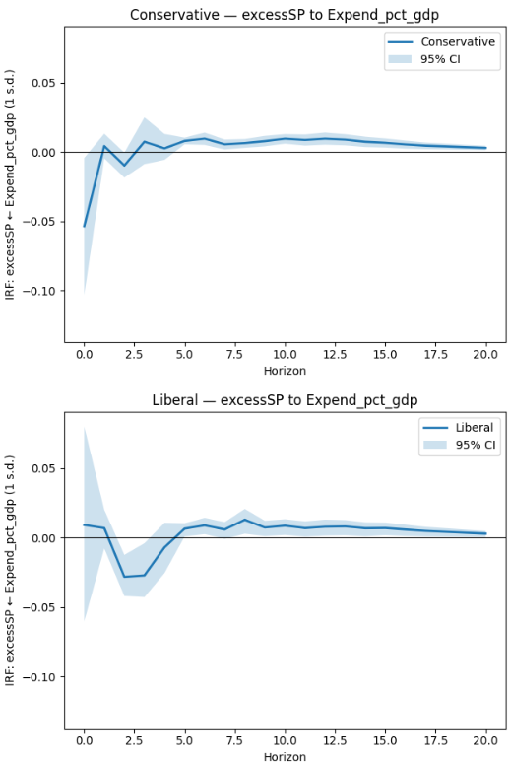

**Figure 10: Shows the IRF of the effect to S&P 500 returns after a tax shock during both regimes using the variable robustness check**

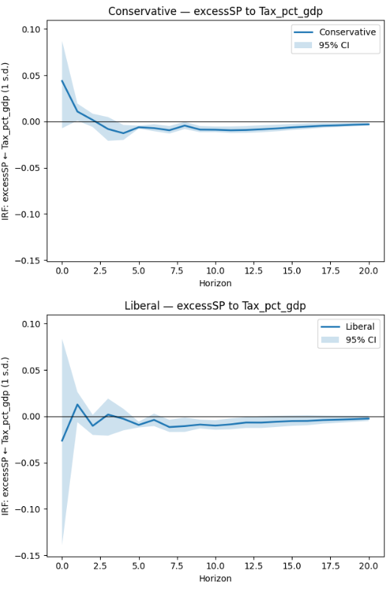

**Table 8: Shows the FEVD response of S&P 500 returns during both regimes using the variable reordering robustness check**

-----------------------------------------------------------------------

FEVD (%) — Conservative | Response: excessSP

Expend_pct_gdp Tax_pct_gdp dGY dINF dFFR excessSP Sum_%

H=1 6.05 4.26 0.28 6.11 0.32 82.98 100.00

H=4 5.72 4.26 2.95 10.11 1.53 75.44 100.01

H=8 6.04 4.55 3.08 10.36 1.53 74.44 100.00

H=12 6.50 5.07 3.03 10.42 1.52 73.46 100.00

H=16 6.76 5.34 2.99 10.75 1.50 72.66 100.00

H=20 6.83 5.42 2.98 10.89 1.49 72.39 100.00

-----------------------------------------------------------------------

-----------------------------------------------------------------------

FEVD (%) — Liberal | Response: excessSP

Expend_pct_gdp Tax_pct_gdp dGY dINF dFFR excessSP Sum_%

H=1 0.30 1.88 2.56 5.35 22.68 67.23 100.00

H=4 3.33 1.91 5.92 6.53 21.51 60.81 100.01

H=8 3.89 2.54 6.06 6.61 21.13 59.77 100.00

H=12 4.28 3.07 5.99 6.64 20.83 59.18 99.99

H=16 4.58 3.28 5.91 6.83 20.69 58.70 99.99

H=20 4.68 3.35 5.89 6.92 20.65 58.52 100.01

-----------------------------------------------------------------------

1. Fatas et al. (2012), stated that, assuming Keynesian theory, fiscal policy can be used to stabilise output.
2. For example, Santa-Clara and Valkanov (2003), Wong et al. (2009), both completed research comparing Republican and Democratic periods.
3. While this has not been explicitly stated, there are a number of papers from universities in Singapore that focus on the use of fiscal policies as a stabilisation method.
4. Local projection models were tested in this study, however, the results were omitted as it involved leads in order to account for the timing issue and this went against traditional literature.
5. Dummy variables and interaction terms were modelled in this study initially. However, the results on the dummy model were omitted as using Cholesky recursive ordering with the dummy variables would assume that other variables in the model could react contemporaneously with the regimes. Therefore it was not a good method and was removed. Interaction terms also did not not work as they were too highly correlated with the overall taxation and spending variables.
6. FRED is an abbreviation for the Federal Reserve Economic Data
7. For example, in 1981:4, the original classification for the quarter was Liberal, but since defence spending as a percentage of GDP increased within the quarter, the classification changed from Liberal to Conservative.
8. For example, 1971 was considered a neutral year as two of the groups were progressive and two were regressive. Therefore the overall period classification was the deciding factor for the partisan classification for 1971. Q1 and Q2 were Conservative and Q3 and Q4 were Liberal.
9. Tavarez and Valkanov (2003) state that an autoregressive root that’s close to 1 will show that an unexpected shock will persist for some time in the future
10. A 90% confidence interval was chosen.